Q. How to resolve following errors when running your Maven Project(Particularly When JDK Version is greater than 8 )

--------------------------------------------------------------------------------------------------------------------------------------------------------------------------------------------

first right click on project -> run as -> maven clean.

first right click on project -> click on maven -> update maven.

[ERROR 1] No compiler is provided in this environment. Perhaps you are running on a JRE rather than a JDK?

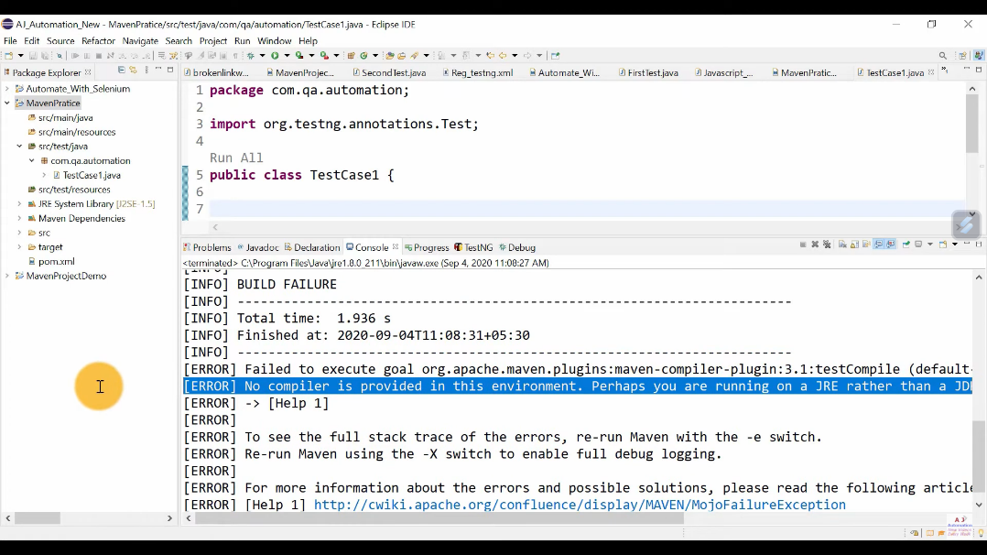

solution :

==> Set JDK as run time environment

1. Go to windows --> Preferences --> Java --> Installed JREs --> Add JDK folder --> Apply and Save.

2. Update maven project.

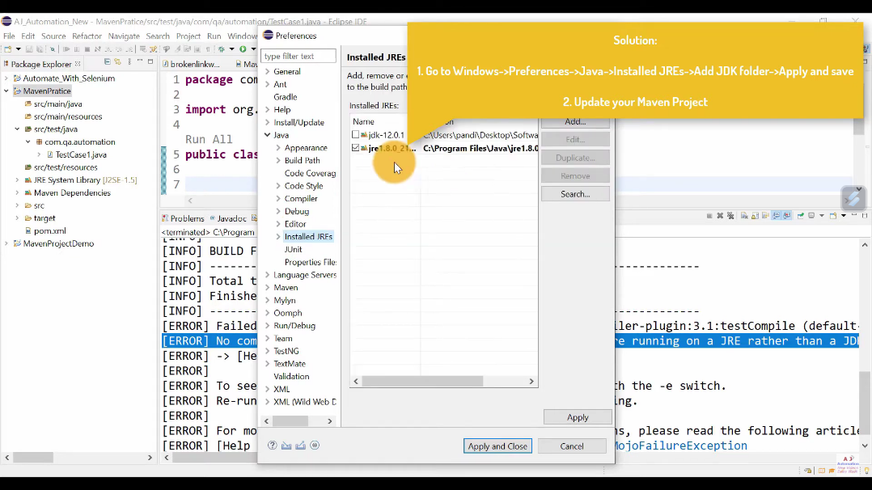

--------------------------------------------------------------------------------------------------------------------------------------------------------------------------------------------

first right click on project -> run as -> maven clean.

first right click on project -> click on maven -> update maven.

[ERROR 2] Source option 6 is no longer supported. Use 7 or later.

[ERROR 2] Target option 6 is no longer supported. Use 7 or later.

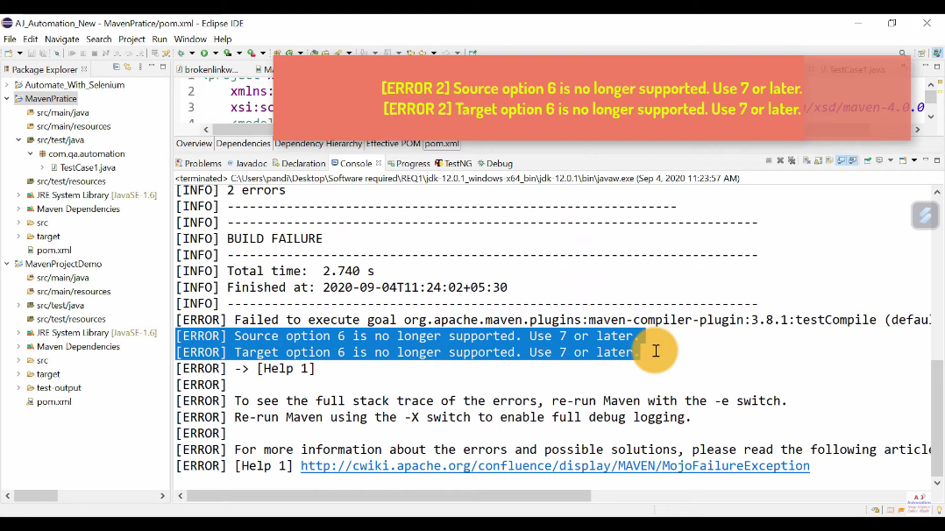

By default Maven Compiler uses 1.6 as Source and Target. So we need to force it to use 1.8 version(Java 8 version) no matter what JDK version u have Set in Installed JREs.

solution :

One way : Add Properties to Set Source and Target as 1.8 in POM.XML

<properties>

<project.build.sourceEncoding>UTF-8</project.build.sourceEncoding>

<maven.compiler.source>1.7</maven.compiler.source>

<maven.compiler.target>1.7</maven.compiler.target>

</properties>

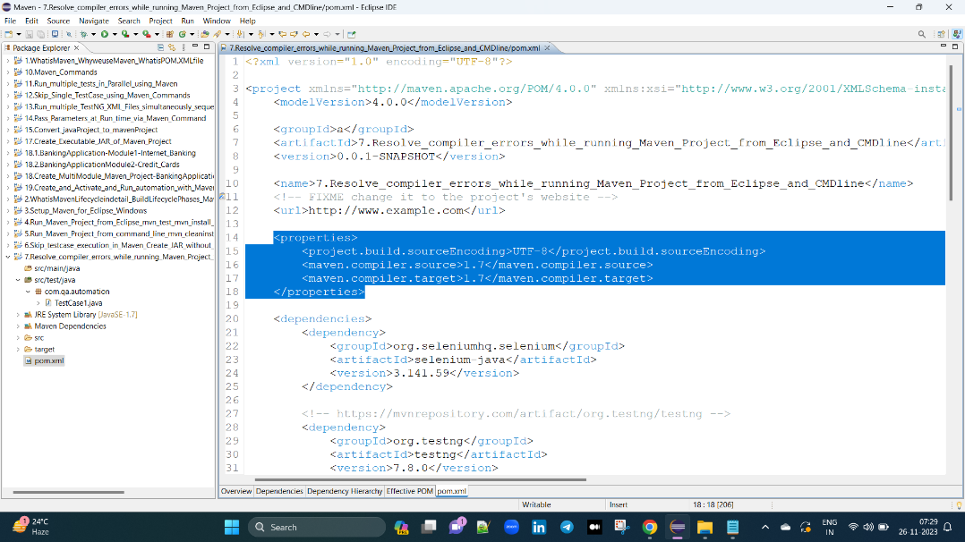

Second way : Configure Maven Compiler plugin to Set Source and Target as 1.8 in POM.XML

<plugin>

<artifactId>maven-compiler-plugin</artifactId>

<version>3.8.0</version>

<configuration>

<source>1.8</source>

<target>1.8</target>

</configuration>

</plugin>

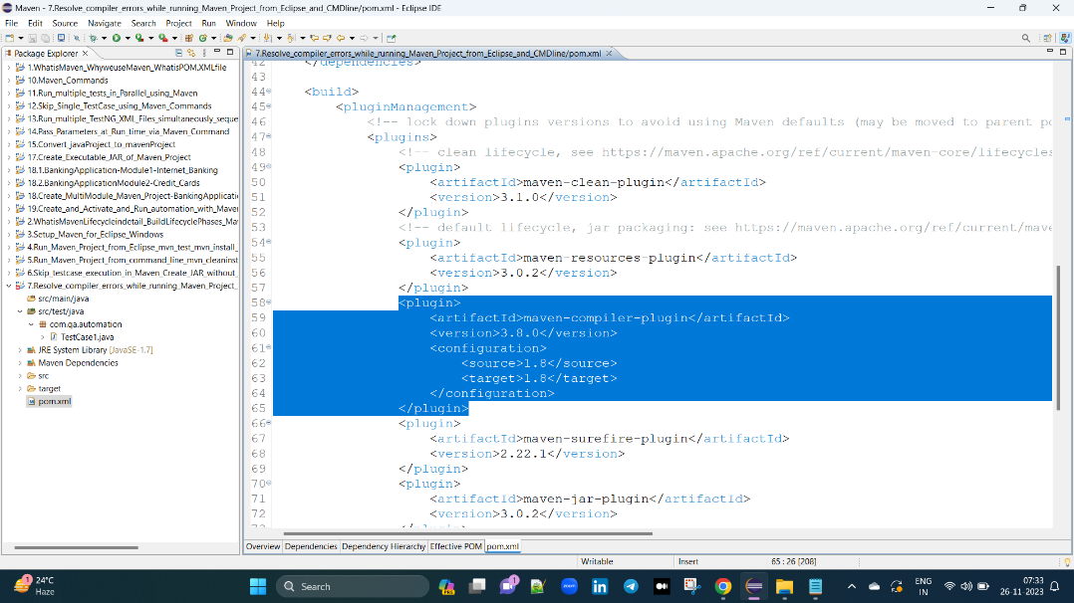

Note : vaka vela pom.xml file lo manam e source and target plugin ela compiler plugin kinda estea paina echina properties tags remove chaiyali.

vako sari cmd tho run cheasinapudu kuda elanti problems vastai apudu environment variables lo java bin path evali apudu antha set right iedi.

Third way : Install JDK 1.8 and Set path in Environmental Variables

e paina two errors ki vaka manchi solution entantea java 1.8v download cheasukoni java_Home and java_path environment variables lo estea saripodi. paina two errors ravu.